3.4.1 Elliptic curves over F_{q}

A finite field is a set of elements that have a finite order (number of elements).The order of Galois Feld (GF) [4] is normally a prime number or a power of a prime number. An elliptic curve E over F_{q} is the set of all solutions (x, y) є F_{q} X F_{q} to an equation called Weierstrass equation (see Appendix A).
y² = x³ + ax + b

where a, b є F_{q} and 4a³ + 27b² ≠ 0, together with a special point ∞ called the point at infinity [8].
It is well known that E is an (additively written) abelian group [4] with the point ∞ serving as its identity element. The rules for group addition are summarized below.
Addition Formulas for the Curve (1). There is a rule, called the chord-and-tangent rule, for adding two points on an elliptic curve E(F_{q}) to give a third elliptic curve point. Together with this addition operation, the set of points E(F_{q}) forms a group with ∞ serving as its identity. It is this group which is used in the construction of elliptic curve cryptosystems. The addition rule is best explained geometrically.

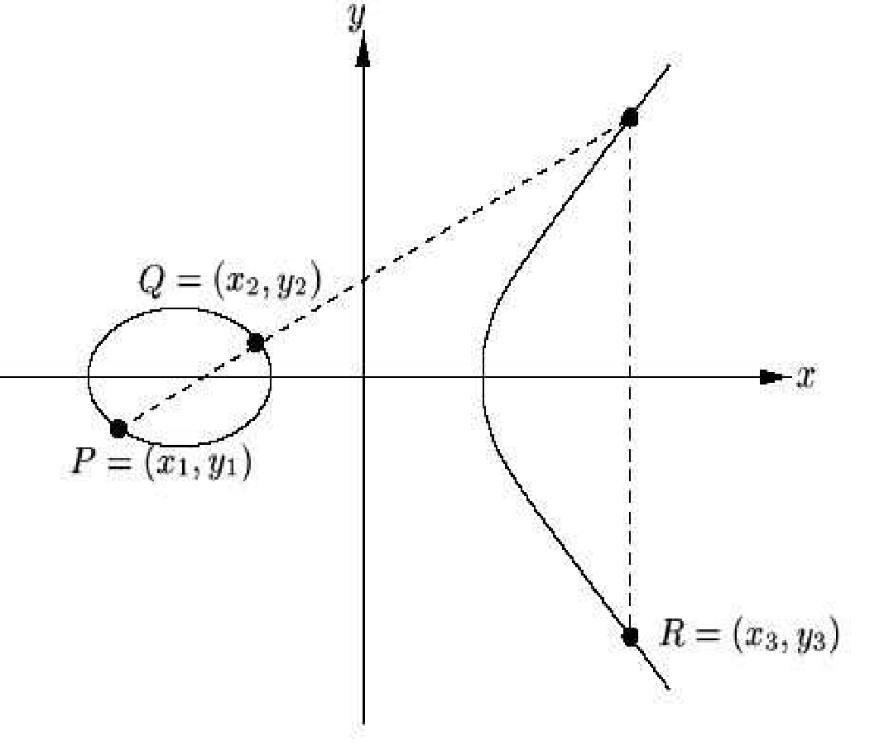

Figure 3.2: Addition of two points P and Q : R = P + Q

Let P(x₁, y₁) and Q(x_{2,} y₂) are the two points on the elliptic curve. Then the sum of P and Q is denoted by another point say R = (x₃, y₃) as it is shown in Figure 3.2
Let P =(x₁, y₁) є E, then -P = (x₁, -y₁). If Q = (x₂, y₂) є E , Q ≠ -P , then P + Q = (x₃, y₃), where
x₃ ₌ λ²- x₁ – x₂
y₃₌ λ ( x₁ – x_{3) –} y₁

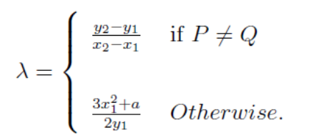

:

The above elliptic curve is said to be non singular if it satisfy the following condition,

4a³ + 27b² ≠ 0

else, the curve is singular.

Adding and doubling points on an elliptic curve C over GF(2^{m}) are defined in a similar way as shown in the Fig. 3.3

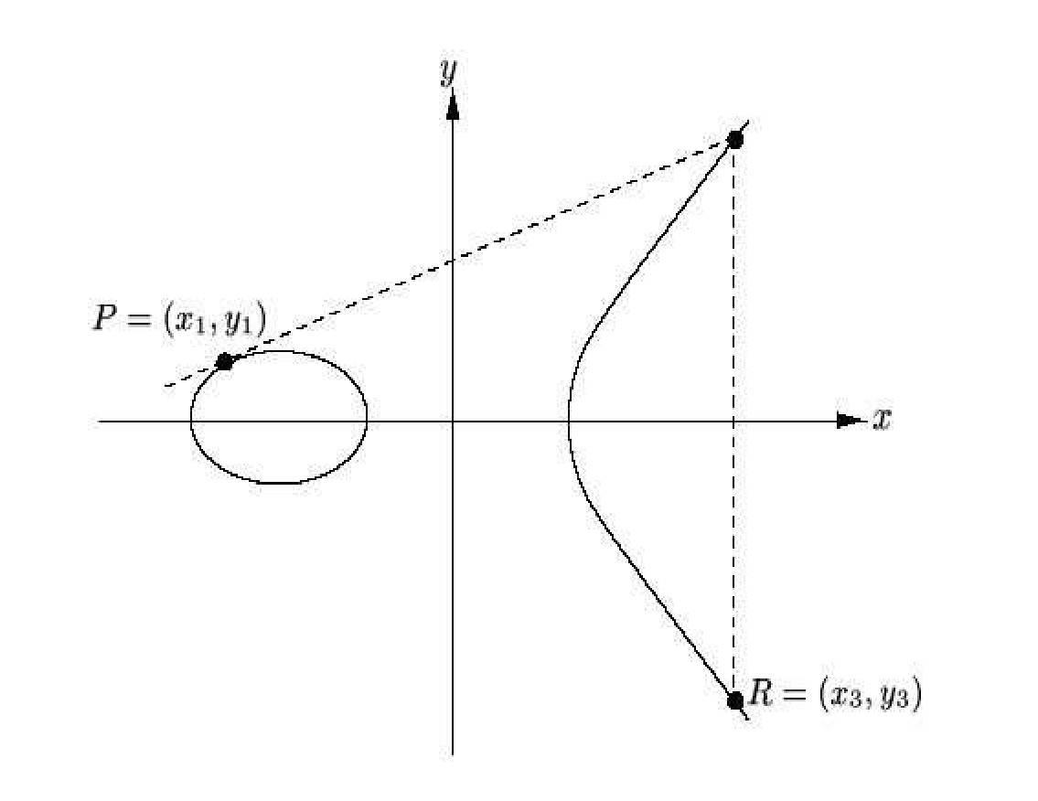

Figure 3.3: Doubling a point P : R=P+P=2P

Excluding the point at infinity ∞, every point P = (x, y) on an elliptic curve C over GF(p^{m}) can be represented as (or "compressed" to) P = (x, y’),where y’ is a single bit:
- if x = 0 then y’ =0.

- if x ≠ 0, then y’ is the parity of y when it is viewed as an integer.

An advantage of compressed representation of a point is that when a compressed point is stored internally in a computer or communicated over a network, it takes only one bit more than half of the bits required for storing or transmitting its uncompressed counterpart. This advantage, however, is not for free: recovering the y-coordinate from a compressed point involves a few arithmetic operations in the underlying finite field .

Elliptic curve point multiplication
Elliptic curve point multiplication is the operation of successively adding a point along an elliptic curve to itself repeatedly. It is used in elliptic curve cryptography (ECC) as a means of producing a trapdoor function. The literature presents this operation as scalar multiplication, thus the most common name is "Elliptic curve scalar multiplication", as written in Hessian form of an elliptic curve.

Basics
Given a curve ξ defined along some equation in a finite field (such as ξ : y² = x³ + ax² + bx + c) we define point multiplication as the repeated addition of a point along that curve. Denote as nP = P + P + P + ... + P for some scalar (integer) n and a point P = (x, y) that lies on the curve ξ.
The security of modern ECC depends on the intractability of determining n from given known values of Q and P. It is known as the elliptic curve discrete logarithm problem.

Point addition
Point addition is defined as taking two points along a curve E and computing where a line through them intersects the curve. We use the negative of the intersection point as the result of the addition.
The operation is denoted by , or . This can algebraically be calculated by:
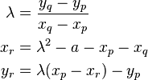
Where a is the multiplication factor of x² in the elliptic field. Note that often, a will be zero, reducing complexity of the equation.

Point doubling
Point doubling is similar to point addition, except we take the tangent of a single point and find the intersection with the tangent line.
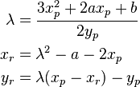
Note that only λ has changed with respect to the point addition problem. Note that we assume that the elliptic field is given by x³ + ax² + bx + c.

Point multiplication
The straightforward way of computing a point multiplication is through repeated addition (with the exception of the first addition since adding a point to itself is usually undefined since the slope of the line through the point is 0). However, this is a fully exponential approach to computing the multiplication.

Double-and-add
The simplest method is the double-and-add method similar to multiply-and-square in modular exponentiation. The algorithm works as follows:
Compute dP with the following representation
* Q = 0
* for i from m to 0 do
* Q := 2Q (using point doubling)
* if d_{i} = 1 then Q := Q + P (using point addition)
* Return Q

An alternative way of writing the above as a recursive function is
f(P, n) is
if n = 0 then return 0 # computation complete
else if n mod 2 = 1 then
P + f(P, n-1) # addition when n is odd
else
f(2P, n/2) # doubling when n is even

where f is the function for doubling, P is the coordinate to double, n is the number of times to double the coordinate. Example: 100P can be written as
2(2(P+2(2(2(P+2P)))))
and thus requires six doublings and two additions. 100P would be equal to f(P,100).

